Git Lab Work-3

1.Create a New Branch “GitNewBranch”

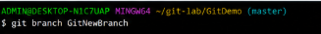

2. List all local and remote branches available
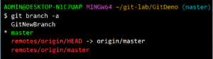

3.Switch to New Created Branch

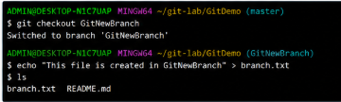

4.Commit the changes in the branch
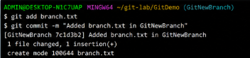

5.Check git status
